Vietnam Cambodia Cruise Tour (Code: FIT15 – P8)

Overview
HANOI – HALONG – SIEM REAP – MEKONG RIVER ON JAYAVARMAN CRUISE – HO CHI MINH CITY
15 DAYS/ 14 NIGHTS

Trip highlights
- EXPLORE ANCIENT ATTRACTION IN THE CAPITAL OF VIETNAM
Take in increadible sights of Hanoi, from the ancient buildings and temples to the bustling streets.
- NIGHT ON CRUISE IN HALONG
Take an overnight cruise through the UNESCO – heritage site of Halong, admiring the scenery and dining on fresh seafood.
- CRUISE THE MEKONG RIVER AND VISIT NUMEROUS ASIAN COUNTRIES
Enjoy the slow rhythm of life on the waterways of the Mekong Delta.
- BE CHARMED BY ONE OF THE MOST BUSTLING METROPOLISES IN VIETNAM
Experience the vibrancy of Saigon and soak up the rich tapestry of history and culture.

BRIEF ITINERARY
DAY 1: HANOI ARRIVAL – CITY TOUR (L)
DAY 2: HALONG ON CRUISE (B / L / D)
DAY 3: HALONG – HANOI (BR)
DAY 4: HANOI – FLY TO SIEM REAP (B)
DAY 5: SIEM REAP CITY TOUR – ANGKOR THOM – BAYON – ANGKOR WAT TEMPLE (B / L)
DAY 6: SIEM REAP – RV JAYAVARMAN CRUISE EMKARKATION (B / L / D)
DAY 7: MEKONG RIVER CRUISE BY RV JAYAVARMAN (B / L / D)
DAY 8: MEKONG RIVER CRUISE BY RV JAYAVARMAN (B / L / D)
DAY 9: MEKONG RIVER CRUISE BY RV JAYAVARMAN (B / L / D)
DAY 10: MEKONG RIVER CRUISE BY RV JAYAVARMAN (B / L / D)
DAY 11: MEKONG RIVER CRUISE BY RV JAYAVARMAN (B / L / D)
DAY 12: MEKONG RIVER CRUISE BY RV JAYAVARMAN (B / L / D)
DAY 13: HO CHI MINH CITY - RV JAYAVARMAN DISEMBARKATION (B)
DAY 14: HO CHI MINH CITY – CU CHI – HO CHI MINH CITY TOUR (B / L)
DAY 15: HO CHI MINH CITY – FLY HOME (B)

DETAILED ITINERARY

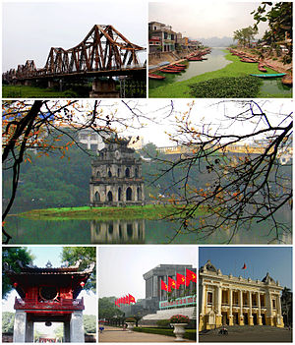
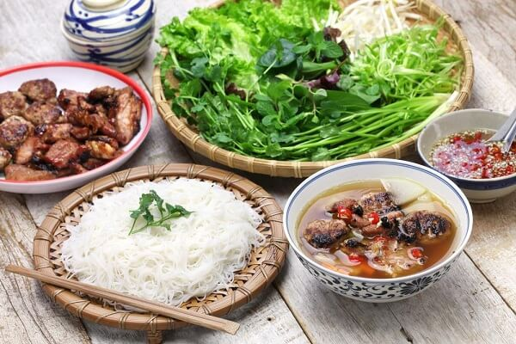
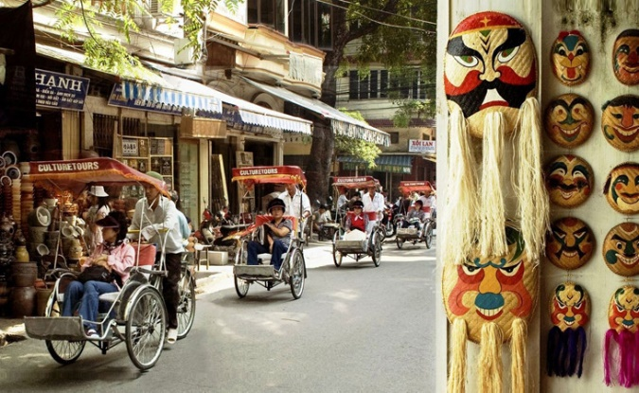
Day 1: Hanoi Arrival (L)
Hanoi – the capital of the Socialist Republic of Vietnam. Large areas of present-day Hanoi were built during the French occupation, reflected in its French-inspired architecture, which come together to give the city a very distinctive charm.
Explore Hanoi by a city tour. This morning segment of the city tour begins with visits to Ho Chi Minh’s Stilt House and Mausoleum, the Presidential Palace and the One Pillar Pagoda, and Hanoi’s oldest place of worship: the thousand year-old Tran Quoc Pagoda.
Lunch at a local restaurant.
The afternoon begins with an extensive Cyclo tour around Hoan Kiem Lake and through the lively streets and alleys of the Old Quarter.
Night in Hanoi.

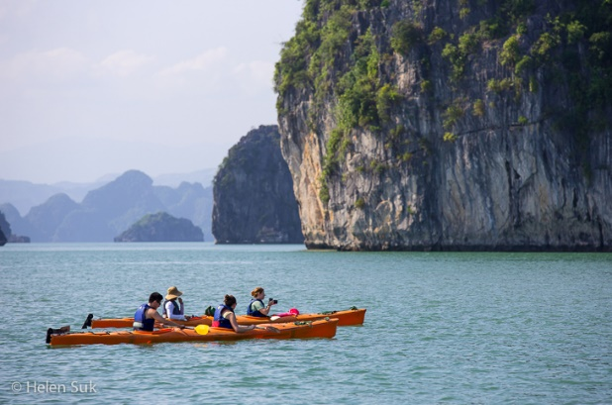
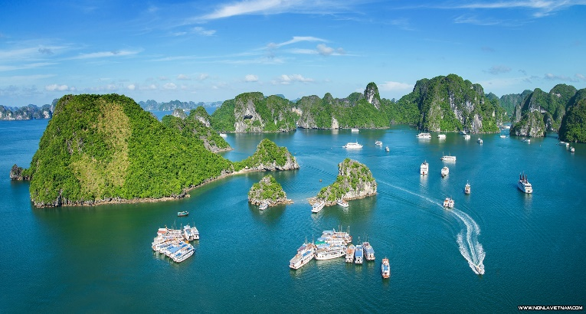
Day 2: Hanoi – Halong (B / L / D)
Embark on a journey by car to Ha Long Bay- a UNESCO World Heritage Site (4 hours). Along the way, beautiful panoramic views of the rural villages and paddy fields of the Red River Delta.
Ha Long Bay is located 165 km east of Ha Noi, in Quang Ninh Province. The site covers an area of 434 square km and comprises 775 limestone islets. Each islet has been marvelously carved by wind and water and through time, stand as sculptures which decorate the vast expanses. Together they are a testament to the forces of nature and live up to the aptly named Bay of the Descending Dragon.
Midday arrival in Ha Long City, check-in on the cruise ship. Seafood lunch-on-the-bay.
Spend the afternoon cruising around Halong Bay’s thousands of limestone islets and caves and see the sun setting over the calm waters. Visit a natural grotto with spectacular formations en-route.
Dinner and night on board the junk amidst the marvels of the bay. In ideal weather conditions, a squid fishing session will be organized.
Night on cruise in Halong Bay.

Day 3: Halong Bay – Hanoi (Br)
Wake up early to watch amazing sunrise over the bay in the morning. Continue cruising before returning to Hanoi. Disembark the cruise around 11 am and return to Hanoi.
Night in Hanoi.

Day 4: Hanoi – Fly To Siem Reap (B)
Transfer to Noi Bai International Airport for a flight to Siem Reap.
Arrival in Siem Reap and our driver will pick you up for a transfer to your hotel.
Night in Siem Reap.

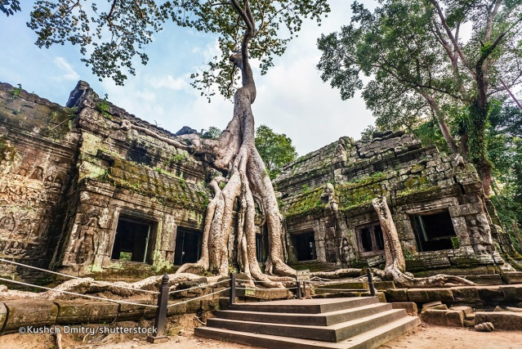
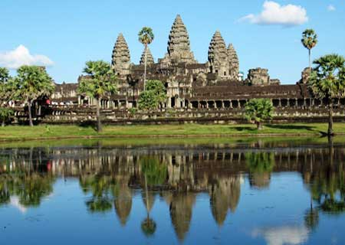
Day 5: Siem Reap (B / L)
Angkor Thom, meaning “Great City” in Khmer, was the last capital city of the Angkorian Empire. Your exploration begins at the South Gate, one of the four gates into the city, which lead to the Bayon. The former state temple best recognized by the hundreds of serenely smiling faces, each over 4 meters tall, sculpted onto some 50 remaining towers. You will walk through narrow maze-like hallways and corridors, stairs and towers to discover the bas-relief decorations that adorn the wall of the monument.
Moving north of Bayon, you will discover the Baphuon, a magnificent 11th Hindu temple converted to the worship of Buddha in the 15th century before entering the Royal Palace grounds. While the Palace itself can no longer be found, the remaining sites are marvels to behold. The Terrace of the Elephants is an impressive two and a half meter tall, 300 meter long terrace wall with carved elephant heads protruding out at several sections, their trunks forming pillars. Phimeanakas - impressive rite and sandstone pyramid. Terrace of the Leper King is at the north end of the Terrace of the Elephants, a double terrace wall with deeply carved nag as, demons and other mythological beings. Be sure to visit the mythical ruins of the Ta Prohm temple where human architectural genius has been overpowered, then complemented by nature over the centuries, as massive trees stand and cast shadows over equally stupendous towers while determinedly grasping them with their roots.
Lunch at a local restaurant.
Just south of Angkor Thom lies the highlight of the UNESCO Heritage Site is Angkor Wat, the pride of Cambodia. The temple complex was built in the 12th century under King Suryavarman II and epitomizes the accomplishment and splendor of Khmer architecture, culture and religion. The five towers that form the temple’s mountain are flanked by galleries with ornate carvings in rose and grey sandstone. As you enter the causeway to cross the moat surrounding the temple, you can begin the visual feast. Try not to miss sunset over Angkor Wat, best viewed from the steps of Pre Rup Temple!
Night in Siem Reap.

Day 6: Siem Reap – Cruise Embarkation (B / L / D)
Meeting point time: VICTORIA ANGKOR RESORT & SPA, Central Park, Siem Reap, Cambodia.
Siem Reap – Kampong Cham
We gather in the morning at our welcome lounge in Siem Reap. Relax with a drink as our staff collects your details for the boarding. Then, we bid farewell to the iconic sights of Angkor and travel over land south to the town of Kampong Cham where our ship awaits us. The transfer takes about 4.5 hours, snacks and water are provided during the trip.
Upon arrival you check in to your well prepared staterooms. A lunch buffet is served in the dining hall. Make yourself familiar with all facilities onboard and take some rest.
In the afternoon we learn more about the education of the young Cambodian generation (NGO project). The children join us on board, always excited to show their skills in music and art. Be sure to be bathed in smiles upon your applause. After the performance, we leave the ship by bus for an afternoon excursion. During low water season, we have the chance to see a bamboo bridge which connects the mainland with an island. Local communities re-build the bridge every year when water levels drop. We continue our land journey to the enchanting pre - Angkorian temple of Wat Hanchey (7th century). This small complex sits on a hill top on the shore with a breath-taking view over the Mekong.
When returning to the ship, you can enjoy some private time until dinner is served in the dining hall. Our lounge cinema features selected classic movies (every night).

Day 7: Siem Reap – Cruise Embarkation (B / L / D)
Kampong Cham – Oknha Tey – Kampong Chhnang
Every morning, our Tai Chi class on the sun deck will give you energy for the day ahead. Breakfast is served in the dining hall.
The ship sails up towards the small Angkor Ban village on the Mekong River. The Angkor Ban village is famous for its unspoiled community and beautiful, traditional houses. It feels like being transported back a hundred years ago, into an era unaffected by modernity. Villagers are characterized by their unbridled warmth. Back on board a Monks’ blessing ceremony will deliver spirits and wishes for health and prosperity for all.
Enjoy your lunch as we set sail downstream the Mekong. In the afternoon a High Tea is offered and our staff is keen to show you the variety of traditional Khmer fashion.
We arrive at the Island of Koh Oknha Tey. This spot in the middle of the Mekong owns its fame for manufacturing high class silk products. By tuk tuk we explore the island with its workshops and learn how silk is processed from its source, provided by little silkworms, to a final top quality product made of original Cambodian silk.
After some additional cruising time, passing the confluence of the Mekong and Tonle Rivers, the boat achors near Kampong Chhnang.
Have a fresh drink before dinner and marvel at the amazing marshlands of this beautiful area.

Day 8: Siem Reap – Cruise Embarkation (B / L / D)
Kampong Chhnang – Kamp. Tralach – Phnom Penh
Wake up early to witness this spectacular scenery at the break of dawn. Our morning Tai Chi class offers the perfect scenery today. Breakfast buffet is served in the dining hall.
We are now in Kampong Chhnang, Cambodia’s “water world”, where everything is on sticks balanced on water rich soil. We take a local boat to the shore. By mini buses we head to a rural village nearby and go on a walking tour. Our guides introduce you to the village specialities – Khmer style pottery and the making of palm sugar. You should defi nitely bring some home. Before returning to the boat, we explore the fl oating villages and wetlands of the region.
Back on board lunch is served while the cruise continues with a languid meander along the Tonle River towards Kampong Tralach. Gliding through leafy swaths of this jungle-like landscape we reach Kampong Tralach. Cacophonous children wave enthusiastically while bringing their livestock for a bath in the meandering river. We will stop at the “Green School” which is partly supported by Heritage Line. See all this river life - which is so different than ours - by a local ox cart ride.
After some additional cruising time the boat arrives at the pier of Phnom Penh. Feel free to have your first exploration by yourself after dinner. Stroll along the river promenade and watch the locals chit-chatting, selling odds and ends or have a drink in one of the numerous bars (kindly inform our crew once you are leaving the ship on your own).

Day 9: Siem Reap – Cruise Embarkation (B / L / D)
Phnom Penh
Welcome to Phnom Penh - the once called Paris of the East. Despite its rapid development, it has retained a lot of its rustic charm and elegance. It is an amazing town with centuries of incredible history and culture which can still be felt at many street corners.
We start with a full sight-seeing tour right after breakfast. By bus we visit the Killing Fields at the outside of the city and afterwards the centrally located prison “S21”. Both historic sites display the sad and cruel chapter of Khmer history when the Khmer Rouge ruled the country with terror and suppression. Those places have not changed much since this horrific time back in the early seventies and it can be quite heartbreaking. Alternatively, you can explore the city in the morning by your own before re-joining the group.
We take lunch at a fine restaurant in town. Our exploration of Phnom Penh continues on the fascinating cultural heritage of Phnom Penh. The golden edifice of the Royal Palace with its Silver Pagoda and the exceptional Khmer crafts at the National Museum are our afternoon highlights. The day trip ends with a “cyclo” ride back to the ship through the bustling streets of downtown Phnom Penh.
Take some rest in your spacious cabin or join other fellow passengers at the bar for refreshing drinks before our captivating evening activities start.
In the early evening a barbecue dinner on the sun deck commences. The dinner is accompanied with an Apsara dance performance. You have to witness the brilliance and richness of this dance along with the soothing sounds of the traditional music.
As the evening unwinds, enjoy your supper with a good glass of wine and marvel at the skyline of Phnom Penh, and the calming flow of the Tonle River.

Day 10: Siem Reap – Cruise Embarkation (B / L / D)
Phnom Penh – Border Crossing – Tan Chau
After breakfast, we gather at the lounge for a great lecture.
The lounge is set up for a captivating lecture about Cambodian mordern history, held by a professor of the Royal University of Phnom Penh. Definitely a highlights of this cruise receiving knowledge first hand as our lecturer has studied the subject extensively and personally.
The whole afternoon is at your own arrangements. From now on, even the last passenger will turn on his cruise mode and hopefully experience the therapeutic influence that this mighty river radiates. It is time for massages, relaxation on the sun bed, and private balcony kick-backs - it’s time to merge with the river.
Some may like to visit the bridge as the captain always has a little story to share about “his” river. Float into a state of mild bliss. Before totally drifting away, do not forget lunchtime around noon.
A culinary class is offered in the afternoon to sharpen your knowledge and skills on the local cuisine. Before slumbering in a nap, join our High Tea with coffee and snacks if you like to. We reach the border and finally arrive in Vietnam. From here it is just a short distance to Tan Chau, a pleasant, slow-paced border town with a sizeable Chinese, Kinh and Khmer community.
We moor near the city with views on the riverbanks.
Dinner will be served soon and you can join our evening cinema with another selected classic movie afterwards.

Day 11: Siem Reap – Cruise Embarkation (B / L / D)
Tan Chau – My An Hung – Sa Dec
Welcome to the fish sanctuary of Vietnam. Begin your day with a hearty breakfast at the dining hall or in the quiet privacy of your balcony.
Brace yourself for a tour around Tan Chau, a pleasant, slow-paced town near the Cambodian border with a sizeable Chinese, Kinh and Khmer community. Once arrival on-shore we hop on “xeloi” to explore Tan Chau. A “xeloi” is a local vehicle which is still used as a taxi in this region. We slowly move around the streets to see all the workshops, houses and domiciles. Get to feel the laidback vibes of this place.
We stop at the colorful, local market near one of the ancient temples. This is the best time to interact with the vendors of this friendly town and make your own bargain experience. We board our local boats and cruise along floating houses until we finally reach a floating fish farm. This region is the source of a fish production that is sold all over the world. We get an exclusive insight in how fish farming works.
Back on board before lunch is served, you may like to pamper yourself with some spa treatments or take a dip into the pool on the sun deck. Our expert guides offer a presentation on the “Life on the Mekong Delta” as the ship continues to My An Hung near the Sa Dec province. Before we arrive mingle with fellow passengers and share some stories.
We will set off for the My An Hung Village. In the village we receive wonderful insights into the private household of a local family. We are allowed to visit their vegetable garden and access the seasonal vegetable fields via crossing a monkey bridge. We are also invited to their house for a Vietnamese tea tasting. Vietnamese tea is often bitter and locals sweeten it with honey. The honey is produced by the family, a true delicacy in this region. We are offered fruits - juicy, fresh, and right from the tree. A local artist group performs a typical traditional dragon dance while we munch on those natural “vitamins bombs”.
As the sun sets and the light bathes everything golden, we settle on a riverbank gathering with cocktails to recap the day.
Back on the ship we cruise downstream the Mekong. Refresh yourself and get ready for dinner. The ship moors mid-river near Sa Dec.

Day 12: Siem Reap – Cruise Embarkation (B / L / D)
Binh Thanh Island – Cai Be – My Tho
In the morning, we arrive at the island of Binh Thanh. We embark on a local boat and head towards Binh Thanh Island. Binh Thanh is one of the larger islands in the vast stream of the Mekong. Some communities have settled here and make their living by growing water hyacinths.
We exclusively visit one of those untouched areas. By wandering through the village we get a deep understanding of the native life. But moreover, we can follow the whole process of their traditional mat making. You can try weaving yourself which is still done manually. We will also meet an old local couple who share their story on this island. They are happy for any chit-chat with you.
Back on board lunch is served and you have some time to leisurely spend onboard while we cruise along the Mekong.
In the early afternoon we arrive in Cai Be, a charming town which is famous for its Catholic French church and their manufacturing of traditional crafts and food products. The floating market of Cai Be is getting smaller every year, since trading on the water is shifting more and more to the modern central markets. We can still see some boat to boat trading of local goods, such as fruits and agricultural products.
Our guide will explain all the particulars of this long lasting trading culture. Each boat has a special marker that lets buyers know what goods they are selling. Afterwards we go on-shore to visit a workshop where we learn how rice paste, rice paper, rice cookies and rice wine is manufactured. Cai Be and its surrounding areas are covered by palm trees and hence the region is also famous for the production of coconut candies. The city is crisscrossed by many water canals. By local boat we will explore the lush and green canal network and observe the farmers working in the fields.
As the sun sets, our crew invites you to a farewell event. Before dinner, you can enjoy dances and music together with the crew. The ship moors at My Tho.

Day 13: Ho Chi Minh City –Disembarkation (B)
My Tho – Ho Chi Minh City
Enjoy your last breakfast aboard your floating home.
We will disembark the ship after breakfast and take a bus transfer from My Tho to the drop off point in Saigon. It is only around 70 kilometers on the highway. You will arrive in Saigon by mid-morning.
We hope you enjoyed this fascinating river cruise, just as our crew does every single time. Moreover, take the enchanting memories and friendships along with you that will linger on with the stories of this amazing river - the Mighty Mekong.
Night in Ho Chi Minh City.

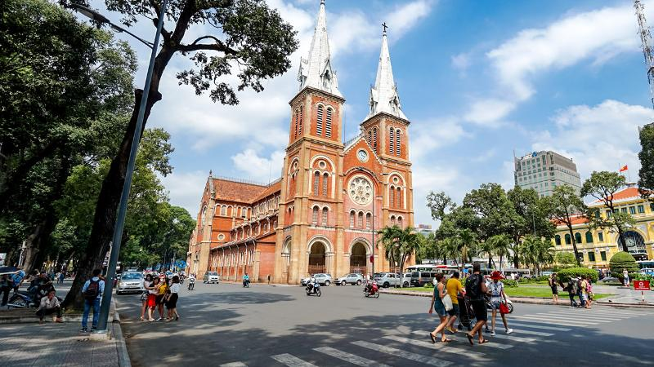
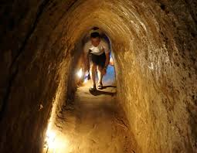
Day 14: Ho Chi Minh City – Cu Chi Tunnel – Ho Chi Minh City (B / L)
Drive 1.5 hours to explore the underground tunnels in Cu Chi. The intricate underground network of tunnels and chambers were first dug in 1948 to assist the Viet Minh against Colonial France and were continually expanded in the following 25 years. At its peak the de-facto underground city housed up to 10,000 people with living areas, kitchens, storage, weapons factories, field hospitals and command centers.
During the American War the entire area of Cu Chi was designated a free fire zone and was heavily bombarded. From 1988, two sections of tunnels have been open for visitors. Now you have a chance to crawl through the tunnels yourself!
Return to Ho Chi Minh City for lunch. In the afternoon, take a walk to visit Reunification Place (former Presidential Place), Dong Khoi Street, Opera House, City Hall or Cathedral. Send your postcards from the pretty French colonial-style post office built by Gustave Eiffel in 1891 and visit the Ben Thanh market, an 11,000 m covered market, which offers the visitor an assortment of local products.
Night in Ho Chi Minh City.

Day 15: Ho Chi Minh City – Fly Home (B)
A day at your own leisure before catching a flight home in the evening.

END OF THE PROGRAM

INCLUDED
- Professional and experienced English speaking guide on day excursion. (All airport transfers without guide)
- Modern and comfortable vehicle with air-conditioner during the trip
- Accommodations with buffet breakfast.
- Meals as mentioned in the itinerary (B=Breakfast, L=Lunch, D=Dinner)
- Entrance fees all sights mentioned per program

EXCLUDED
- Flight ticket
- Vietnam visa fee
- Other meals not clearly described in the program
- Travel insurance
- Tips and Personal expenses such as drinks, telephone, and laundry (tip suggestion but NOT compulsory)

