Beauty of Vietnam (Code: FIT14 – P11)
Overview
HANOI / NINH BINH / HALONG / HOI AN / HUE / HO CHI MINH CITY /
MEKONG DELTA ON MANGO CRUISE
14 DAYS/ 13 NIGHTS

Trip highlights
- EXPLORE ANCIENT ATTRACTION IN THE CAPITAL OF VIETNAM
Take in incredible sights of Hanoi, from the ancient buildings and temples to the bustling streets.
- NIGHT ON CRUISE IN HALONG
Take an overnight cruise through the UNESCO – heritage site of Halong, admiring the scenery and dining on fresh seafood.
- DISCOVER THE CENTRAL VIETNAM
Wander Hoi An’s stunning ancient city and witness the beautiful historical heritage of this city.
- BE CHARMED BY ONE OF THE MOST BUSTLING METROPOLISES IN VIETNAM
Experience the vibrancy of Saigon and soak up the rich tapestry of history and culture.

BRIEF ITINERARY
DAY 1: HANOI ARRIVAL – CITY TOUR (L)
DAY 2: NINH BINH – DAY EXCURSION (B / L)
DAY 3: HALONG ON CRUISE (B / L / D)
DAY 4: HALONG – HANOI (Br)
DAY 5: HANOI – FLY TO DANANG – HOI AN (B)
DAY 6: HOI AN (B / L)
DAY 7: HOI AN (B)
DAY 8: HOI AN – DA NANG – HUE (B)
DAY 9: HUE (B / L)
DAY 10: HUE – FLY TO HO CHI MINH CITY (B)
DAY 11: HO CHI MINH CITY – BEN TRE – MANGO CRUISE EMBARKATION (B / L / D)
DAY 12: MEKONG DELTA – MANGO CRUISE (B / L / D)
DAY 13: MANGO CRUISE DISEMBARKATION – CAN THO – HO CHI MINH CITY (B)
DAY 14: HO CHI MINH CITY – FLY HOME (B)

DETAILED ITINERARY

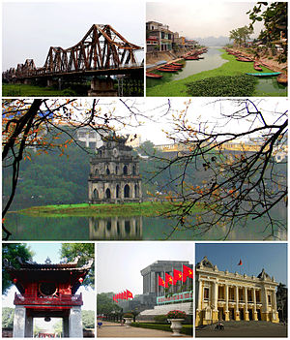
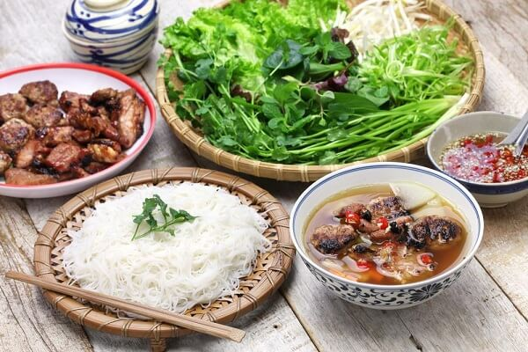
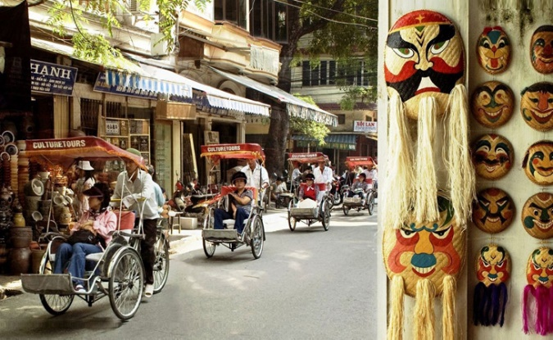
Day 1: Hanoi (L)
Morning city tour to visit Ho Chi Minh’s Stilt House and Mausoleum, the President Place, One Pillar Pagoda, the thousand year-old Tran Quoc Pagoda and Temple of Literature – the first university of Vietnam.
Extensive Cyclo tour around Hoan Kiem Lake and through the lively streets and alleys of the Old Quarter in the afternoon.
Night in Hanoi.

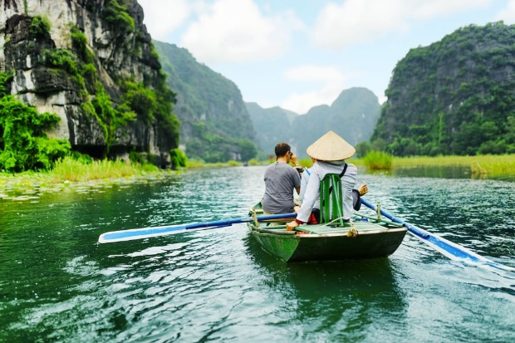
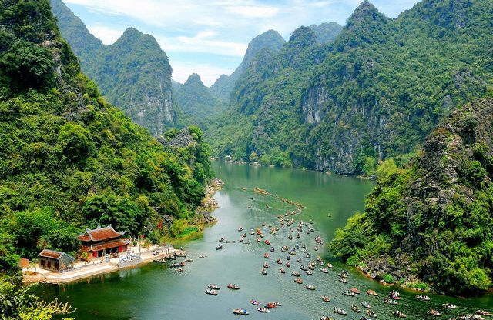
Day 2: Ninh Binh (B / L)
Transfer to Ninh Binh city (2.5 hours by car). Visit Trang An Scenic Landscape Complex, a UNESCO World Heritage Site. Board a small row boat and enjoy the spectacular natural beauty of “Ha Long on land” and its karst mountains – where the newly - released blockbuster Kong: Skull Island was filmed.
After lunch, take a short row boat ride to visit Thien Ha Cave. Carved inside the Tuong Mountain which used to be a natural wall of the ancient Hoa Lu Capital, the cave is a complex of dry caves and an underground river. Archaeological excavation inside the cave found traces of shells, bone, stone tools of ancient Vietnamese people. Admire the lustre of the lively stalactites during your exploration.
Return to Hanoi in the late afternoon.
Night in Hanoi.

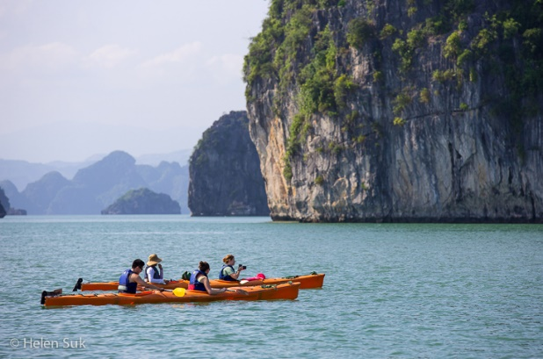
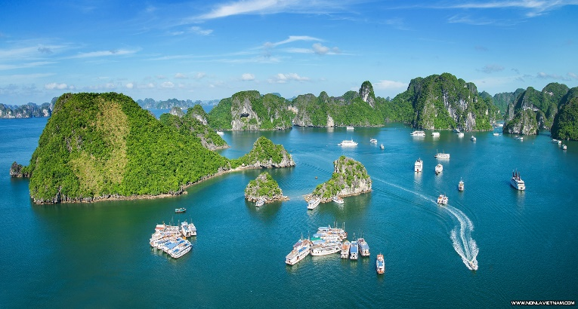
Day 3: Hanoi – Halong (B / L / D)
After breakfast, embark on a journey to Ha Long Bay- a UNESCO World Heritage Site (4 hour by car). Along the way, beautiful panoramic views of the rural village and paddy fileds of the Red River Delta.
Midday arrival in Ha Long city and board a junk cruise. Seafood lunch on the bay.
Spend the afternoon cruising around Halong Bay’s thousands of limestione islets and caves. Visit a natural grotto with spectacular formations en-route.
Night on cruise in Halong Bay.

Day 4: Halong Bay – Hanoi (Br)
Wake up early to watch amazing sunrise over the bay in the morning. Continue cruising before returning to Hanoi. Disembark the cruise around 11 am and return to Hanoi.
Night in Hanoi.

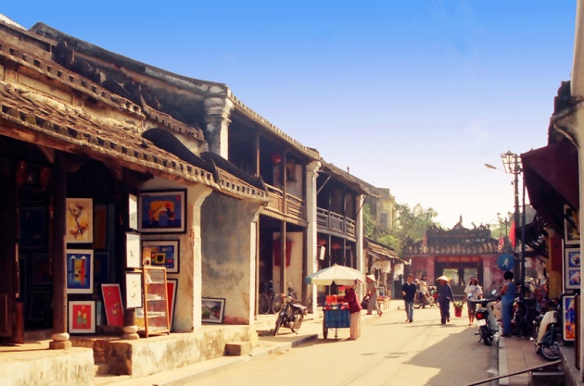
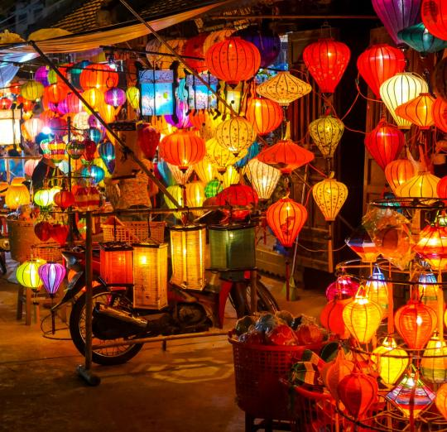
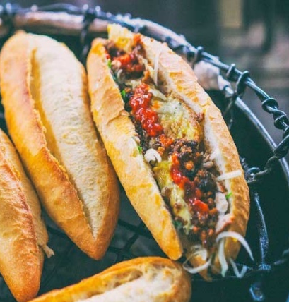
Day 5: Hanoi – Fly To Da Nang – Hoi An (B / L)
After a short flight (1 hour) to Da Nang city, transfer to Hoi An and explore the UNESCO town of Hoi An by a walking tour with your guide, visiting Chua Ong Pagoda, Chinese Assembly Halls, Tan Ky ancestral house, and the Japanese Bridge.
Lunch at a local restaurant.
Night in Hoi An.

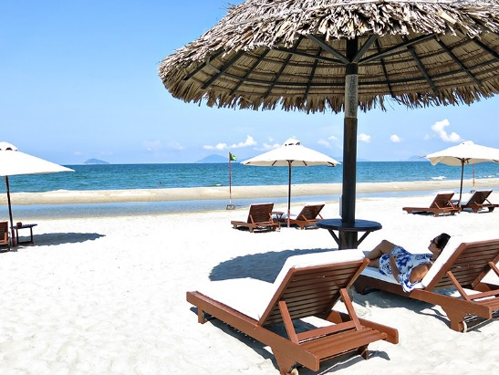
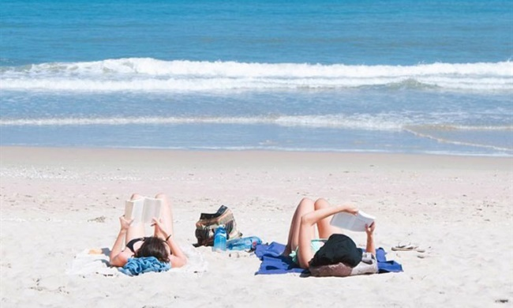
Day 6 – 7: Hoi An (B)
Free to relax and explore at your own leisure. You might like to enjoy the beach or take a walk to the riverside near your hotel to explore the local shops. Grab a “Banh Mi”, a world-famous local bread.
Night in Hoi An.

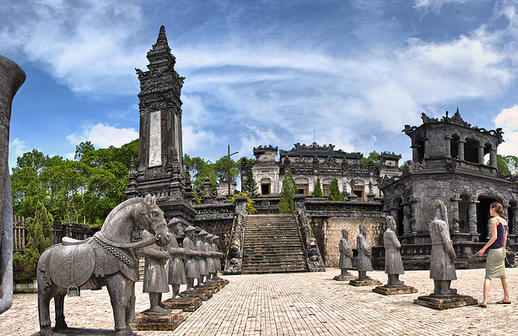
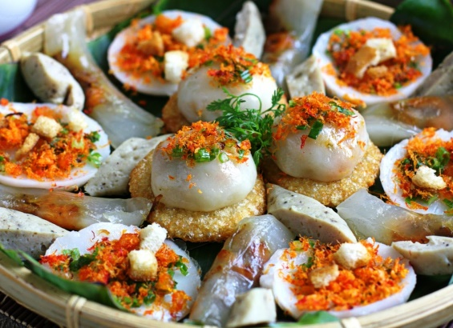
Day 8: Hue (B / L)
After breakfast, drive from Hoi An to Hue. Travel over the Hai Van Pass, which on a clear day has spectacular views out to the East Sea and the Lang Co peninsula.
Arrival in Hue and exploring the Imperial City, known as the Citadel, with your guide - which was actually a walled fortress and palace belonged to the ancient city of Hue which was a capital city of the Nguyen Dynasty for 140 years back from 1805 until 1945.
Visit the Thien Mu Pagoda, one of the main institution for Buddhism in Vietnam. Then visit a local market.
Night in Hue.

Day 9: Hue (B)
Free to explore the peaceful Hue city. You might want to visit the tomb of Emperor Tu Duc (1848-1883) or Emperor Khai Dinh (1916-1925). Emperor Tu Duc’s tomb is one of the most beautiful works of royal architecture of the Nguyen dynasty. The hillside monument of Emperor Khai Dinh is a synthesis of Vietnamese and European elements which took 11 years of construction. Most of the tomb’s grandiose exterior is covered in blackened concrete, creating an unexpectedly Gothic air, while the interiors resemble an explosion of colourful mosaic.
Night in Hue.

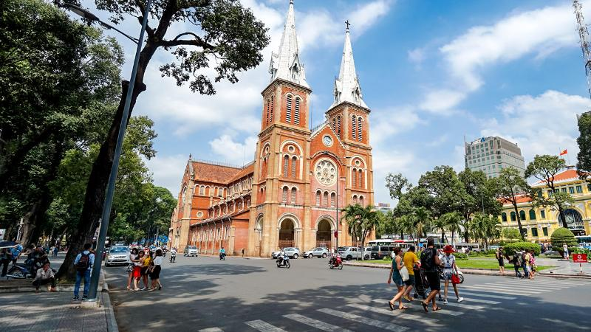
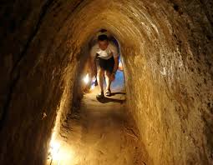
Day 10: Hue – Fly To Ho Chi Minh City – Cu Chi – Ho Chi Minh City (B / L)
A short flight (1.5 hours) takes you to vibrant Ho Chi Minh City (Saigon). Drive 1.5 hours to explore the underground tunnels in Cu Chi. The intricate underground network of tunnels and chambers were first dug in 1948 to assist the Viet Minh against Colonial France and were continually expanded in the following 25 years. At its peak the de-facto underground city housed up to 10,000 people with living areas, kitchens, storage, weapons factories, field hospitals and command centers.
During the American War, the entire area of Cu Chi was designated a free fire zone and was heavily bombarded. From 1988, two sections of tunnels have been open for visitors. Now you have a chance to crawl through the tunnels yourself!
Return to Ho Chi Minh City for lunch.
Night in Ho Chi Minh City.

Day 11: Ho Chi Minh City – Ben Tre – on Cruise (B / L / D)
Depart for Ben Tre for your trip on Mango Cruise. You will board the boat at Ba Dung pier in Ben Tre and head to An Hoa River. The cruise will take you to Phong Nam village in Giong Trom, where you will ride a bike through the village to explore the local daily life.
Stop at a local house to taste the tropical fruits and chat with the farmer. Visit the rice noodle factory which supply to most local markets in the area.
Continue to take a rowing sampan boat through the small canals, which are covered green by the water coconut tree.
As you reach the big river, your sampan is waiting for you and lunch will be served on board.
After lunch, your boat will bring you to My Long village where you meet with a local family, a former Vietcong soldier who survived two years fighting the Khmer Rouge in Phnom Penh. Now he and his wife live on making rice paper, which is the most famous specialty of My Long village. Have a chat with him and enjoy the crispy rice paper made by his wife, and learn how to do the rice paper.
Return to the boat and continue cruising to Mo Cay canals. Stop for a visit at the coconut processing workshop where you can see how the locals utilize every bit of the coconut. Cruise to Vung Liem Canal where your sampan will dock for an overnight.
Relax and freshen up for your cooking demonstration and dinner on board. The rest of the evening will be spent at your leisure.
Night on cruise.

Day 12: On Cruise – Vinh Liem – Tra On (B / L / D)
Walk up early to see the beautiful sunset on the river. Then visit a brick factory to find out how bricks are handmade by traditional way. Continue to take the bike ride through green paddies, gardens and local villages to explore the untouched beauty of this region.
Head to the town of Vung Liem and visit the Cao Dai Temple.

On the way to Tra On, you will stop at Cai Nhum village on the bank of Mang Thit River for a walk. It’s an opportunity to appreciate the local life and the hospitality of the people here.
Return to your boat and cruising to Can Tho. Enjoy the sunset on the deck with refreshment. Your dinner will be served afterwards. The rest of the evening is spent at your leisure.
The ship will dock near Can Tho City for an overnight.

Day 13: On Cruise – Tra On – Cai Rang – Can Tho – Ho Chi Minh City (B)
Freshen up for an early trip to the spectacular Cai Rang floating market, where you will transfer to a smaller boat and mingle amongst the thousands of trading vessels. Feel free to buy yourself fruits or drinks from the local boats.
Disembark at Ninh Kieu Pier in Can Tho City and return to Ho Chi Minh City.
Night in Ho Chi Minh City.

Day 14: Ho Chi Minh City – Fly Home (B)
A day at your own leisure before catching a flight home in the evening. Take a walk to visit Reunification Place (former Presidential Place), Dong Khoi Street, Opera House, City Hall or Cathedral. Send your postcards from the pretty French colonial-style post office built by Gustave Eiffel in 1891 and visit the Ben Thanh market, an 11,000 m covered market, which offers the visitor an assortment of local products. Grab a bowl of seafood “Banh canh” soup, a local favourite.

END OF THE PROGRAM

INCLUDED
- Professional and experienced English speaking guide on day excursion and half day tour (All airport transfers without guide)
- Modern and comfortable vehicle with air-conditioner during the trip
- Accommodations with buffet breakfast.
- Meals as mentioned in the itinerary (B=Breakfast, L=Lunch, D=Dinner)
- Entrance fees all sights mentioned per program

EXCLUDED
- Flight ticket
- Vietnam visa fee
- Other meals not clearly described in the program
- Travel insurance
- Tips and Personal expenses such as drinks, telephone, and laundry (tip suggestion but NOT compulsory)

