Natural Wonders of Vietnam (Code: FIT10 – P5)

Overview
HANOI / MAI CHAU / NINH BINH / SAPA / HALONG
10 Days/ 9 Nights
PRICE
From $US 2033 USD
Single Supplement: extra from $US 784

TRIP HIGHLIGHT
- EXPLORE HISTORIC HOA LU
Visit Vietnam’s first capital and admire the tombs of the former emperors and the crumbling walls of the Citadel.
- TREK ON THE NORTHERN MOUNTAINS
Discover the “the Rooftop of Southeast Asia”- Fan Si Pan Mount and experience the natural scenery of Northern Vietnam.
- NIGHT ON CRUISE IN HALONG
Take an overnight cruise through the UNESCO – heritage site of Halong, admire the scenery and dine on fresh seafood.

BRIEF ITINERARY
DAY 1: HANOI ARRIVAL – CITY TOUR (L)
DAY 2: HANOI – MAI CHAU (B / L)
DAY 3: MAI CHAU (B / L / D)
DAY 4: MAI CHAU – HANOI (B / L)
DAY 5: MAI CHAU – NINH BINH (B / L)
DAY 6: NINH BINH – HANOI – SAPA (B / L / D)
DAY 7: SAPA (B / L)
DAY 8: SAPA – HANOI (B / D)
DAY 9: HANOI – HALONG – NIGHT ON CRUISE (B / L / D)
DAY 10: HALONG – HANOI – FLY HOME (BR / D)

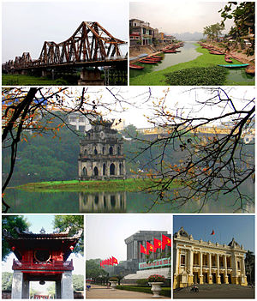
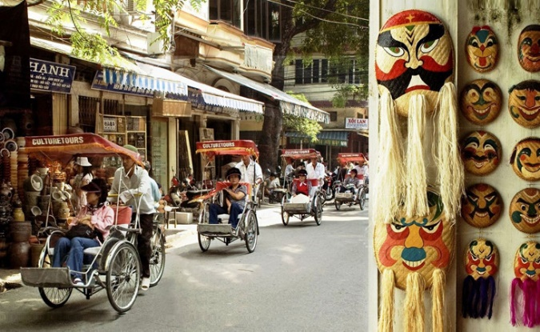
Day 1: Hanoi Arrival (L)
Hanoi is the capital of the Socialist Republic of Vietnam. Large areas of present-day Hanoi were built during the French occupation, reflected in its French-inspired architecture, which come together to give the city a very distinctive charm.

This morning segment of the city tour begins with visit to Ho Chi Minh’s Stilt House, outside of the Mausoleum and the Presidential Palace, the One Pillar Pagoda, and Hanoi’s oldest place of worship situated on the shore of the West Lake: the thousand-year-old Tran Quoc Pagoda.
Lunch at a local restaurant.
In the afternoon, visit the Vietnam’s first university - the Temple of Literature; followed by an extensive Cyclo tour around Hoan Kiem Lake and through the lively streets and alleys of the Old Quarter.
Night in Hanoi.

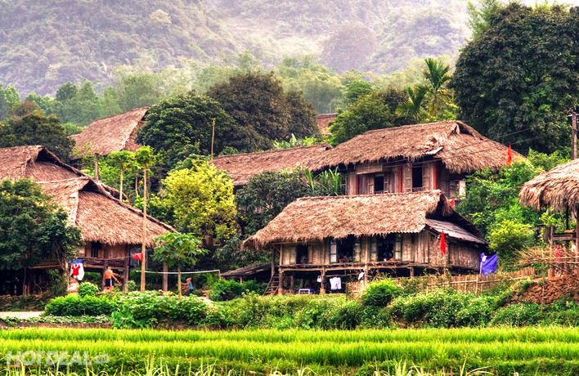
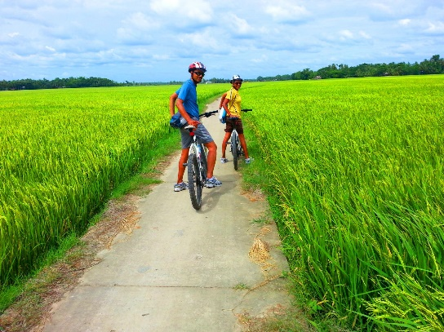
Day 2: Hanoi – Mai Chau (B / L / D)
In the morning, departure for your trip to Mai Chau Valley in Hoa Binh province (3.5 hours by car). Escape the bustle and hustle of the city, spend your day exploring Lac Village – home to the local White Thai people for 700 years. Ideally nested amongst the stunning mountain ranges of Mai Chau, the village is a green valley of paddy fields dotted with rows of stilt houses.
Take your bike and explore the beautiful village. Enjoy dinner with local food and sit back to enjoy a traditional dance performance.
Night in Mai Chau.

Day 3: Mai Chau (B / L)
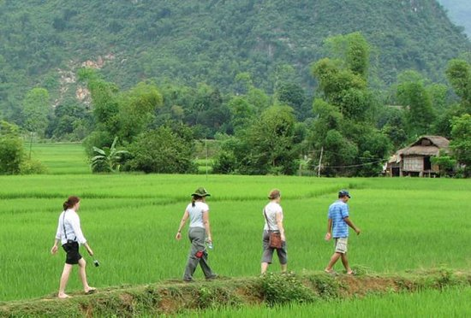
Trek to visit some of the Thai minorities who call this valley home. Drop off at some local stilt house to see the local residents. The tour guide also takes you to Mo Luong Cave, a natural cave in the limestone blocks with magnificent stalactites.
The rest of the day is at your leisure.
Night in Mai Chau.

Day 4: Mai Chau – Ninh Binh (B / L)
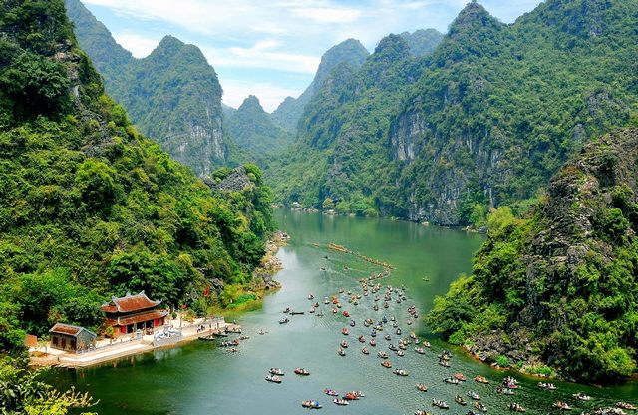

Depart for Ninh Binh city. Visit Trang An Scenic Landscape Complex, a UNESCO World Heritage Site. Board a small row boat and enjoy the spectacular natural beauty of “Ha Long on land” and its karst mountains – where the newly - released blockbuster Kong- Skull Island was filmed.
Situated near the southern margin of the Red River Delta, the Trang An Landscape Complex is a spectacular landscape of limestone karst peaks permeated with valleys, many of them partly submerged and surrounded by steel, almost vertical cliffs. Exploration of caves at different altitudes has revealed archaeological traces of human activity over a continuous period of 30, 000 years. They illustrate the occupation of these mountains by seasonal hunter-gatherers and how they adapted to major climatic and environment changes, especially the repeated inundation of the landscape by the sea after the last ice age. The story of human occupation continues through the Neolithic and Bronze Ages to the historical era. Hoa Lu, the ancient capital of Vietnam, was strategically established here in the 10th and 11th centuries AD.
Night in Ninh Binh.

Day 5: Ninh Binh – Hanoi – Lao Cai (B / L / D)
Morning bike to visit an old village in Ninh Binh to witness the daily life of the Red River Delta and visit the Temples of King Dinh and King Le which were built in the 17th century.
The temples are dedicated to King Dinh and King Le, the two kings who lived in 10th century and chose Hoa Lu to build the citadel of the capital city. From time to time, archaeologists have excavated buried parts of this citadel and found rusty weapons and ceramics.
After lunch, continue your visit to Thung Nham Bird Garden, home of 46 species of birds including some bird species recorded in the Vietnam Red Book of endangered species.
Surrounded by tropical forest strips on Limestone Mountains with many valleys and caves, along with natural plants and untouched flora, Thung Nham ecotourism zone is the convergence of the beautiful natural landscapes and unique scenery.

Board a small row boat, you will creep through the flooded forest, immerse in the nature and waters, and explore the wild beauty of the caves and soak up the romantic scenery in valley of love.
In the afternoon, transfer to Hanoi Railway Station where you get on train heading to Lao Cai city. Spend the night on air-conditioned train in a 4 beds compartment.
Night on train.

Day 6: Lao Cai – Sapa (B / L)
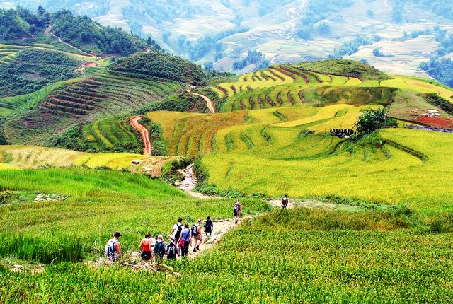
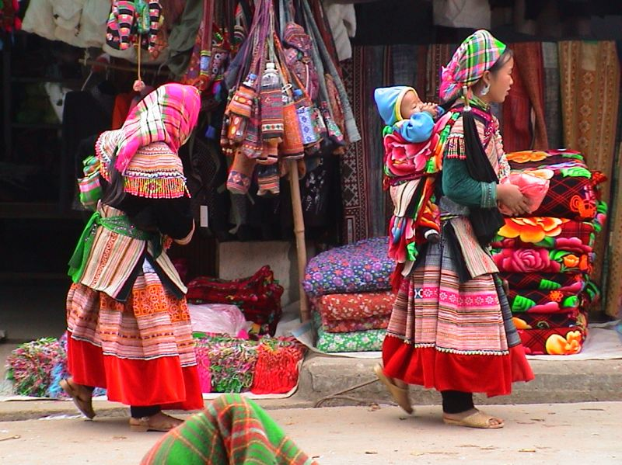
Arrival in Lao Cai city and transfer by car to Sapa town (about 1 hour).
Established as a hill station by the French in 1922, Sapa is home of the Red Dao, Black H’mong, Tay and other ethnic minority people. Although modern tourism development has mushroomed haphazardly in the town, this is northern Vietnam’s premier trekking base from where hikers launch themselves into a surrounding countryside off cascading rice terraces and tiny hill- tribe villages that seem a world apart. Once you’ve stepped out into the lush fields, you will understand the Sapa area’s real charm.
Trek south of Sapa towards the busy village of Cat Cat located at the bottom of Muong Hoa Valley and near the stunning Cat Cat waterfall. This is an old village of H’mong ethnic. Dip your toes in the cool mountain waters, watch local children fishing with nets and continue deeper through the villages and terraces of the H’mong.
In the afternoon, free time to relax or walk to Sapa central town for a visit to the market and Sapa Stone Cathedral. Local hill tribes fill the town with color of their traditional costumes.
Night in Sapa.

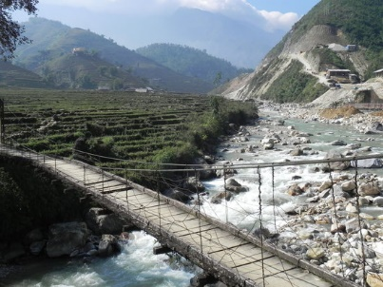
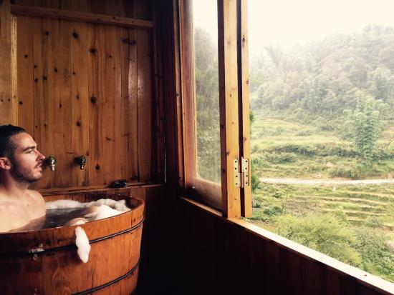
Day 7: Sapa (B / L)
After breakfast, transfer out of town to the remote village Ta Phin with a rich culture that has not been damaged by the modern life. Stroll through the surrounding countryside and enjoy the picturesque landscape of spectacular rice fields, mountains, streams and hill tribe houses.
Drop by the Red Dao tribe’s traditional herbal spa where natural herbs are brewed overnight. You can take a private room to dip yourself in the hot medicated bath with a view over the lust landscape.
Afternoon at leisure.
Night in Sapa.

Day 8: Sapa – Fanxipang – Hanoi (B / D)
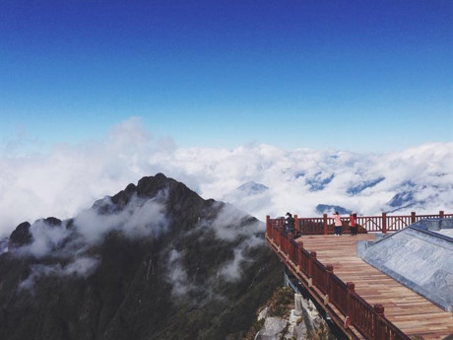
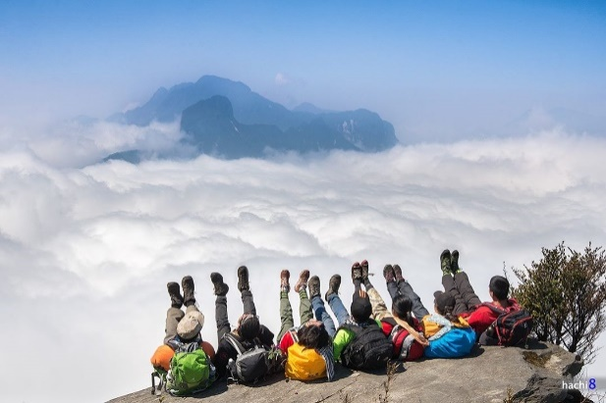
Free time in the morning to explore Sapa town until check out.
In the afternoon, transfer by car to the Fansipan cable-car station to begin the trip discovering the Mount of Fansipan, also known as the Rooftop of Indochina. Make sure you don’t miss out on this spectacular wonder of nature and experience Vietnam like nowhere else.
In the evening, transfer back to Lao Cai Railway Station to catch an overnight train to Hanoi.
Night on train.

Day 9: Hanoi – Halong (B / L / D)
After breakfast, depart Hanoi for the famous Ha Long Bay - The World Heritage Site recognized by UNESCO in 1994. Along the way, it would be wonderful to catch beautiful view of rural villages and paddy fields of the Red river Delta.
Ha Long Bay is located in the northeast corner of Viet Nam, 165 km from Ha Noi, belongs to the Province of Quang Ninh. The site covers an area of 434 sq. Km, including 775 islands, of which 411 are named. This is a wonderful and skilful masterpiece of the Creation and of nature that turns thousands of dumb soulless stone islands into fantastic sculptural Thousands of islands emerging uneven in the fanciful waves look strong and magnificent but also mild and vivid.
Mid- day arrival in Ha Long city and check-in on a junk cruise. Then, a seafood lunch will be served.
Spend the afternoon cruising around Ha Long Bay’s thousands of limestone islets and caves and see the sun setting over the calm waters. Visit a cave on route.
Dinner and night on cruise in Ha Long.
To end the day and depend on the weather, a night fishing session will be organized.

Day 9: Halong – Hanoi – Fly Home (BR)
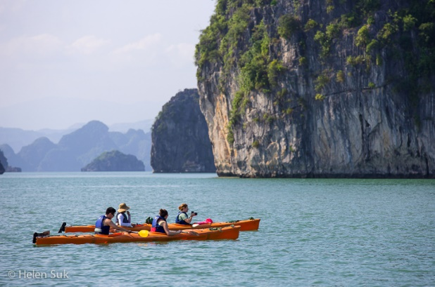
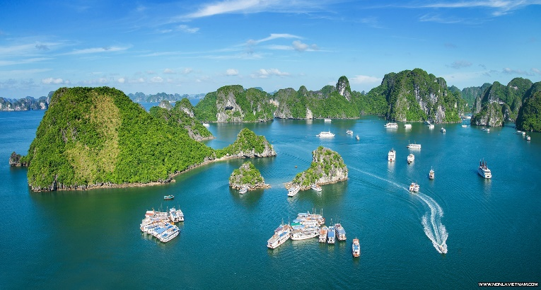
Wake up early to watch amazing sunrise over the bay in the morning. Continue cruising before returning to Hanoi. Disembark the cruise and transfer back to Hanoi.
Enjoy a Water Puppet Show before transferring to Noi Bai International Airport for your return flight.
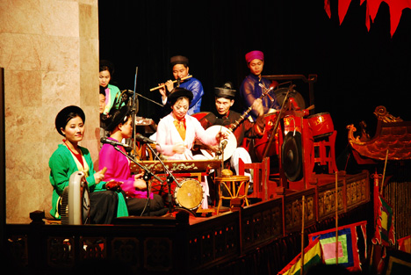
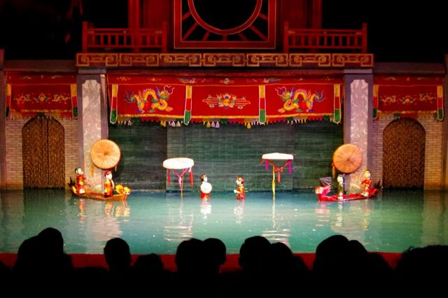
END OF THE PROGRAM

INCLUDED
- Accommodation in a shared twin or double room
- Meals according to the program (B: Breakfast; L: Lunch; D: Dinner)
- Transfer by private car and driver (all airport transfer without a guide)
- Train tickets as mentioned in the itinerary (shared 4 compartments cabin)
- Boat trip as mentioned in the itinerary
- Excursion fees according to the itinerary.
- Private tour with English-speaking tour guide (for other languages supplements apply)

EXCLUDED
- International and domestic Flight.
- Visa for Vietnam (Visa issued on arrival for most nationalities, $US 45/ person. Please check with our Travel consultant for more detailed information)
- Travel Insurance (health, cancellation, luggage, repatriation)
- Personal expenses: Drinks, telephone calls, tips, laundry and expenditure of a personal nature
- Services and meals not mentioned in the program.

